Aboubacar Tounkara My mini world: Antique Bookstore

For my project, I chose the Antique Bookstore mini world. An antique bookstore is a shop or bookstore like the name suggests that sells old, rare, and collectible books that you usually can’t find in regular bookstores. To understand what the system needs, I started by researchiing how real antique bookstores operate. I looked at popular websites like The Strand Bookstore and AbeBooks to see how they describe rare books, how they organize their catalogs, and how they handle customer purchases. This helped me understand what kind of information is important for antique books, such as condition, publication year, and price. I also emailed them asking questions about the books which surprisingly they responded within 2 days, and I also talked to a friend who buys books a lot, and they gave me ideas about what information the store track. From all of this, I got a clear picture of how an antique bookstore system should work and what data it needs to store.
Based on what I learned, I identified the main functional requirements for the system. The system needs to store detailed information about each antique book, including the title, author, publication year, condition, and price. It also needs to manage customer information so the store can keep track of who is purchasing books. Another important part is processing orders, which mean the system should also be able to create new orders, calculate totals, and link each order to a customer. Since one order can include multiple books, the system also needs a way to store order items separately. If the bookstore works with dealers who supply rare books, the system should also keep track of dealer information and which books they provided.
For the non functional requirements, I focused on things that make the system reliable and easy to use. Data accuracy is of course important because antique books can be valuable, and mistakes in condition or price could cause problems. The system also needs to protect inventory so the same rare book isn’t sold twice. I want the system to make it easy to search for books or look up customer orders quickly. Security matters too, especially for customer information, so only authorized people should be able to change important data. Finally, the system should run smoothly and handle searches efficiently even as the bookstore adds more books over time.

These are the entities and their attributes I will use in my database design as well as what I’ll use as my primary keys and foreign keys:
1. BOOKS
- bookID (Primary Key)
- title
- author
- publicationYear
- genre
- condition
- price
- dealerID (Foreign Key --> DEALERS) (Can be a person, organization or company)
2. CUSTOMERS
- customerID (Primary Key)
- firstName
- lastName
- email
- phone
3. ORDERS
- orderID (Primary Key)
- orderDate
- totalAmount
- customerID (Foreign Key --> CUSTOMERS)
4. ORDER_ITEMS
- orderItemID (Primary Key)
- orderID (Foreign Key --> ORDERS)
- bookID (Foreign Key --> BOOKS)
- quantity
- itemPrice
5. DEALERS
- dealerID (Primary Key)
- name
- email
- phone

Chen Style ER Diagram by hand.
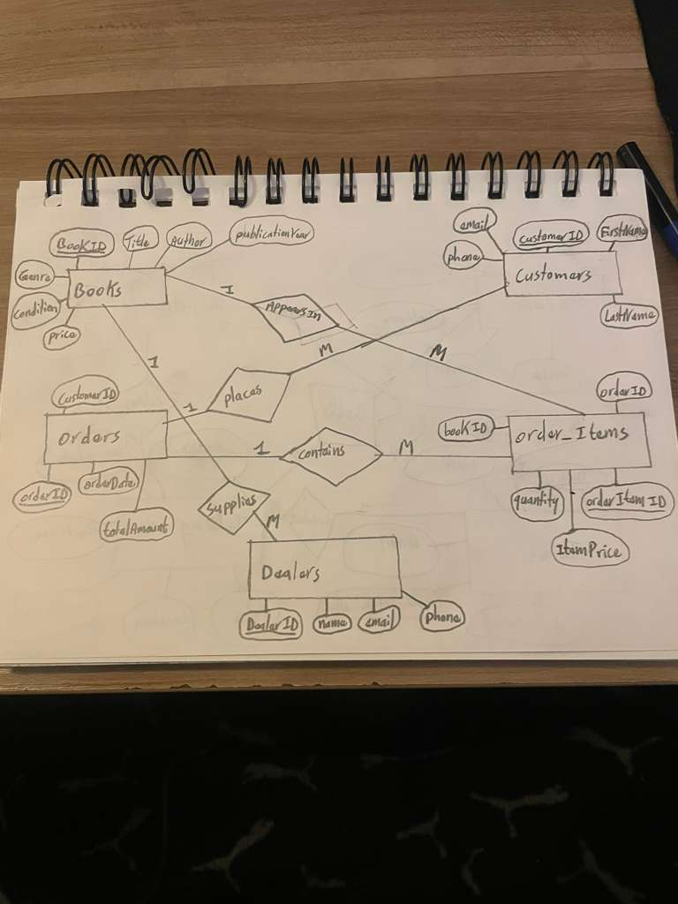

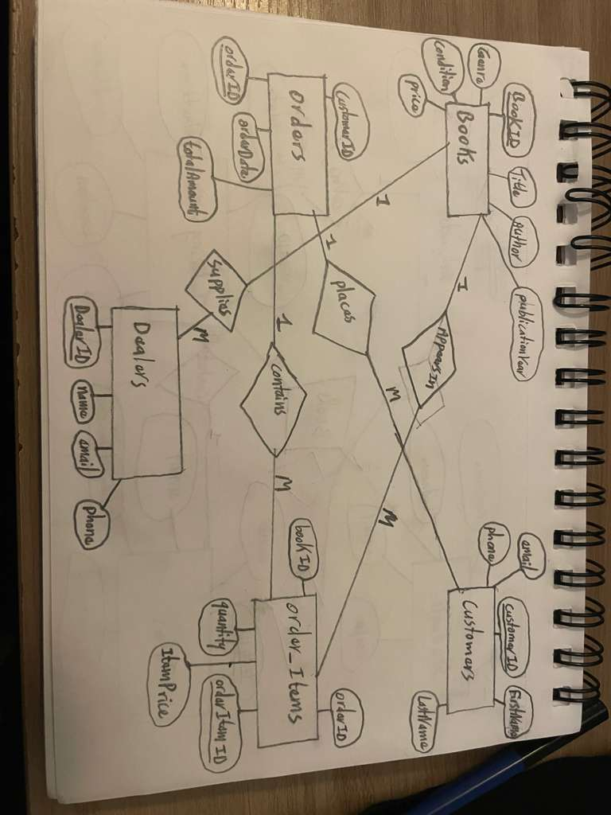
UML Style ER Diagram

